Blockchain and it’s Applications
Question Bank Unit 2 Missing
- What are smart Contracts. Explain various types of smart contracts
Ans .1) Smart contracts are self-executing contracts with the terms of the agreement directly written into lines of code. These contracts automatically enforce and execute the terms of an agreement when predefined conditions are met. They run on blockchain technology, ensuring transparency, security, and immutability.

There are various types of smart contracts based on their functionality and the blockchain network they operate on:

1. Simple Smart Contracts These are basic contracts with straightforward conditions and actions. They execute predefined actions when specific conditions are met.

2. Complex Smart Contracts These contracts involve multiple conditions and actions, allowing for more intricate agreements to be automated. They can handle a series of conditional statements and execute various actions based on different scenarios.

3. Multi-signature Smart Contracts Also known as multi-sig contracts, these require multiple parties to sign off on a transaction before it can be executed. They are commonly used for escrow services and joint accounts.

4. Oracle Smart Contracts These contracts interact with external data sources, known as oracles, to trigger actions based on real-world events. Oracles provide the smart contract with information from outside the blockchain.

5. Token Smart Contracts These contracts govern the creation, distribution, and management of tokens on a blockchain. They are commonly used for Initial Coin Offerings (ICOs), tokenization of assets, and creating decentralized applications (dApps).

6. Permissioned Smart Contracts These contracts operate on permissioned blockchains where access is restricted to authorized participants. They are suitable for enterprise applications that require privacy and control over network participants.

By leveraging smart contracts, parties can automate and streamline various processes, reduce the need for intermediaries, and ensure trustless execution of agreements. Smart contracts have the potential to revolutionize industries by enabling secure, transparent, and efficient transactions on blockchain networks.
- What is Blockchain. Draw and Explain structure of Block and block header.
Ans.2) A blockchain is a decentralized and distributed ledger technology that securely records and verifies transactions across a network of computers. It consists of a chain of blocks, each containing a list of transactions, linked together through cryptographic hashes. Blockchain is designed to be transparent, secure, and tamper-resistant, providing a reliable and decentralized way to record and verify digital transactions without the need for a central authority.

Structure of a Block: Each block in a blockchain contains specific information and follows a consistent structure. While there may be some variations depending on the blockchain platform, the fundamental components of a block typically include:
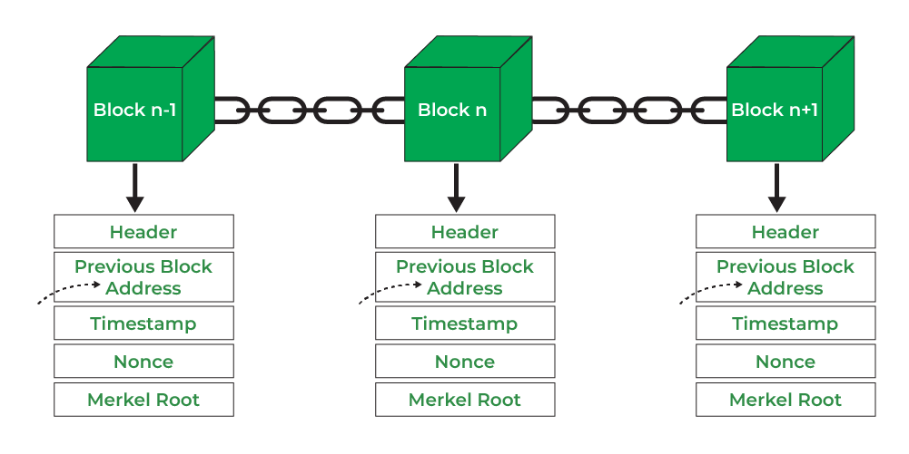

- Header: It is used to identify the particular block in the entire blockchain. It handles all blocks in the blockchain. A block header is hashed periodically by miners by changing the nonce value as part of normal mining activity, also Three sets of block metadata are contained in the block header.

- Previous Block Address/ Hash: It is used to connect the i+1th block to the ith block using the hash. In short, it is a reference to the hash of the previous (parent) block in the chain.

- Timestamp: It is a system verify the data into the block and assigns a time or date of creation for digital documents. The timestamp is a string of characters that uniquely identifies the document or event and indicates when it was created.

- Nonce: A nonce number which uses only once. It is a central part of the proof of work in the block. It is compared to the live target if it is smaller or equal to the current target. People who mine, test, and eliminate many Nonce per second until they find that Valuable Nonce is valid.

- Merkel Root: It is a type of data structure frame of different blocks of data. A Merkle Tree stores all the transactions in a block by producing a digital fingerprint of the entire transaction. It allows the users to verify whether a transaction can be included in a block or not.

The structure and consensus mechanisms may vary in different blockchain implementations, but the core principles of transparency, security, and decentralization remain consistent across blockchain technology.

The block header is a crucial component of a blockchain's structure, located at the beginning of each block. It contains essential information about the block and serves as the means to link one block to the previous block, forming the chain. The block header is hashed to create a unique identifier for the block, and it includes several key fields:
- Version Number:
Indicates the version of the blockchain protocol being used. This helps in maintaining compatibility and understanding the rules by which the block is validated.

- Previous Block Hash:
A reference to the hash of the previous block in the blockchain. This establishes the chronological order and continuity of the blockchain, as each block is linked to its predecessor.

- Merkle Root:
The Merkle root is the cryptographic hash of all the transactions included in the block. It is generated by organizing the transaction hashes in a Merkle tree structure, where each leaf node is a transaction hash, and the internal nodes are the hashes of their respective children. The Merkle root is a concise representation of all transactions in the block.

- Timestamp:
Indicates the time when the block is created. It helps in maintaining a chronological order and is a crucial factor in the consensus mechanism, especially for adjusting the difficulty of mining.

- Difficulty Target:
Represents the level of difficulty set for miners to find a valid hash. It is an important parameter that adjusts periodically to control the rate of block creation, ensuring a consistent block time.

- Nonce:
A random number used in the mining process. Miners repeatedly modify the nonce until a hash is found that meets the current difficulty target. The inclusion of the nonce ensures that the block's hash satisfies the network's consensus rules.

The block header is hashed using a cryptographic hash function, typically SHA-256 (Secure Hash Algorithm 256-bit), producing a fixed-length string of characters known as the block hash. This hash uniquely identifies the block and is a critical factor in the security and integrity of the blockchain. Even a small change in any part of the block header would result in a completely different hash, making it tamper-evident.

The linking of blocks through the block header's reference to the previous block's hash ensures the immutability and security of the entire blockchain. If an attacker were to alter the data in any block, it would change the block's hash, invalidating not only that block but also all subsequent blocks in the chain. This makes the blockchain resistant to tampering and provides a transparent and trustless record of transactions.

